Women Who Changed History
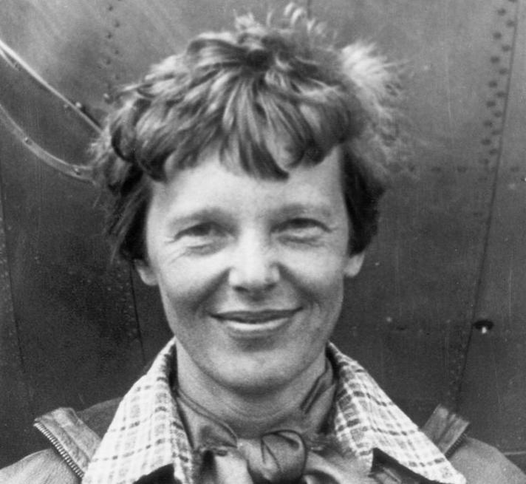
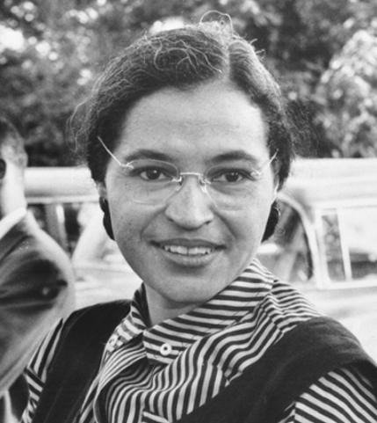
Rosa Parks was the first black woman to stand up for black human rights. She refused to give up her seat on a public bus to a white man. She is mostly known as THE MOTHER of the Civil Rights movement. Rosa died in October 2005 at the age of 92. She was arrested for the violation but was bailed out a few hours later.
Rosa Parks Amelia Earhart
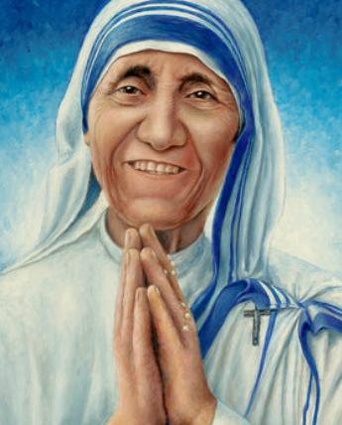
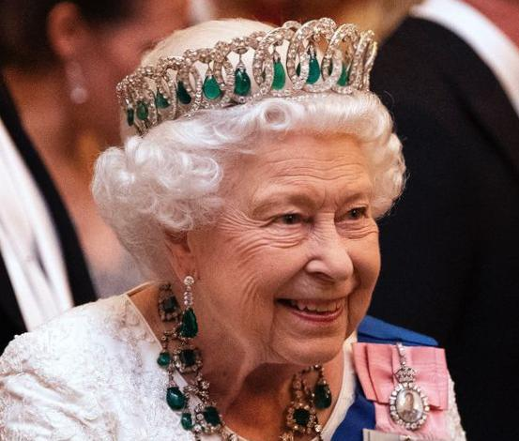
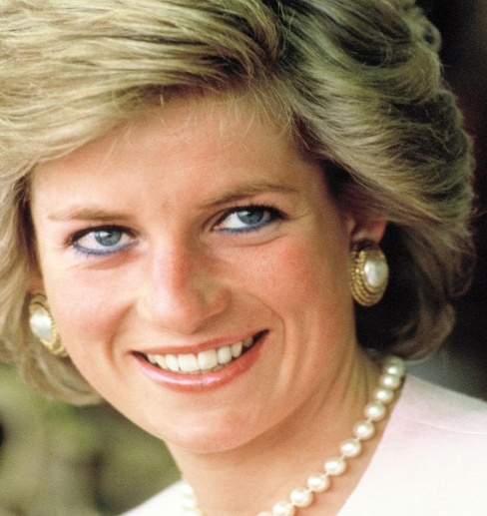
Amelia Earhart was the first female to fly solo across the whole Atlantic Ocean. She became the first person to fly solo from Hawaii to California. In the attempt to be the first woman to fly solo around the world, Amelia went missing in 1937. She was declared dead in 1939.
Lady Diana Queen Elizabeth the Second Mother Teresa
Diana Frances Spencer also known as Lady Diana was a member of the British royal family. She was the first wife of Charles the Third and mother of Wiliam and Harry. Diana sadly died on Sunday, June 31st, 1997. In the year of 1992, she and her husband agreed to separate.
Queen Elizabeth II was the Queen of the United Kingdom of Great Britain and Northern Ireland. Queen Elizabeth sadly died at the age of 96 on September 8th, 2022. The Queen ruled for longer than any other Monarch in British history, becoming a much-loved and respected figure across the globe.
Mother Teresa was an Albanian Roman Catholic nun. She won the Nobel Peace Prize in 1979. She visited Metković with Father Ante Gabrić. She worked and lived in India for 17 years. She taught us to treat everyone with kindness, respect, and most importantly love.

